FINAL PROJECT REPORT
COLLEGE TIMETABLE GENERATOR
An Algorithm-Based Web Application for Conflict-Free Academic Scheduling

Student Name(s): ______________________________
Roll Number(s): ______________________________
Department: B.Tech – Artificial Intelligence & Machine Learning
College: ______________________________
Guide Name: ______________________________
Academic Year: 2026–2027

1. Abstract & Introduction

1.1 Abstract
The College Timetable Generator is an algorithm-centric web application designed to generate conflict-free academic timetables from information such as subjects, faculty, rooms, student batches and available time slots. Manual timetable preparation can require repeated checking of faculty conflicts, room conflicts and batch conflicts. The proposed system automates this process and provides a clear interface for entering scheduling resources and generating a timetable.
The core scheduling engine uses three algorithmic strategies: Greedy scheduling, Graph Coloring and Backtracking. Conflict checks ensure that a faculty member, room or student batch is not assigned to incompatible classes at the same time. The implementation also handles infeasible inputs without crashing by returning a partial result together with information about unscheduled classes. Repeatable tests were created for a sample fixture containing 5 subjects, 3 faculty members, 2 rooms, 2 batches and 6 time slots.

1.2 Introduction
Academic timetable generation is a constraint-satisfaction problem. A valid schedule must assign classes to available time slots and resources while respecting multiple constraints. In a college environment, the same faculty member should not teach two classes simultaneously, the same room should not host two classes simultaneously, and the same batch should not be scheduled for two classes simultaneously. Faculty availability is another important constraint.
The project converts this real-world scheduling problem into a working algorithmic prototype. Instead of producing only a final timetable, the system is designed to expose the scheduling strategy and conflict checks so that the decisions made by the algorithms can be inspected.

2. Problem Statement, Objectives & Scope

2.1 Problem Statement
Generate conflict-free class timetables from subjects, faculty, rooms and availability. The system must avoid faculty, room and student-batch clashes while respecting the supplied faculty availability.

2.2 Objectives
- Automate the generation of college class timetables.
- Avoid faculty, room and student-batch clashes.
- Respect faculty availability and supplied scheduling constraints.
- Implement and demonstrate Greedy, Graph Coloring and Backtracking approaches.
- Provide a web interface through which scheduling resources can be managed.
- Show the generated timetable and make important scheduling decisions understandable.
- Handle impossible scheduling inputs gracefully instead of terminating with an application crash.
- Provide repeatable automated tests for the scheduling algorithms.

2.3 Project Scope
- Manage subjects, faculty, rooms and student batches used by the scheduler.
- Represent available academic time slots.
- Generate schedules using multiple algorithmic strategies.
- Perform conflict checking for faculty, rooms and batches.
- Respect faculty availability constraints.
- Display the generated schedule through a web interface.
- Record or expose scheduling decisions through a decision-trace concept.
- Return partial schedules and unscheduled-class information when a complete schedule is impossible.

2.4 Target Users
- College timetable coordinators
- Department coordinators
- Faculty or academic administrators
- Academic scheduling teams

3. Features & Functional Requirements

3.1 Main Features
- Dashboard for the college scheduling workspace.
- Management of scheduling resources such as subjects, faculty, rooms and batches.
- Selection of a scheduling algorithm/strategy.
- Automatic timetable generation.
- Conflict checking for faculty, room and batch resources.
- Faculty availability handling.
- Decision-trace / scheduling-decision visibility.
- Recent-run/history area for generated schedules.
- Graceful handling of infeasible schedules.

3.2 User Functionalities
- Add scheduling resources.
- View existing resources.
- Edit resource information.
- Delete resources where permitted.
- Select a scheduling strategy.
- Generate a timetable.
- Review the resulting timetable.
- Inspect conflicts or unscheduled classes when a complete schedule cannot be produced.

3.3 CRUD Operations
CRUD represents Create, Read, Update and Delete operations. For a timetable management system, these operations are applicable to resource records such as subjects, faculty, rooms and batches.
Operation | Purpose | Example
Create | Add a new resource | Add a subject, faculty member, room or batch
Read | View stored resources | Display all registered subjects
Update | Modify an existing resource | Change faculty availability
Delete | Remove a resource | Remove an unused room

3.4 Authentication & Validation
Input validation is important because invalid or incomplete scheduling data can produce incorrect results. Required fields should be checked before a resource is stored or a timetable is generated. Where authentication is enabled in the submitted application, protected management functions should be accessible only to authenticated users. Authentication should not be described as implemented unless the final submitted code contains the corresponding login/session or token mechanism.
For the current algorithm test evidence, the verified focus is scheduling correctness, conflict checking, availability handling and graceful handling of impossible schedules.

3.5 System Requirements
Category | Requirement
Operating System | Windows / Linux / macOS
Programming Language | Python 3.x
Web Framework | Flask
Frontend | HTML5, CSS3, JavaScript
Database | SQLite
Browser | Modern web browser such as Chrome, Edge or Firefox
Development Tool | VS Code or another Python-compatible IDE
Testing | Python test framework such as pytest

4. Algorithms & Methodology

4.1 System Workflow
- Enter or manage subjects, faculty, rooms and batches.
- Define or load available time slots and faculty availability.
- Select a scheduling strategy.
- Represent scheduling constraints and resource usage.
- Assign classes to feasible time/resource combinations.
- Check faculty, room and batch conflicts after each assignment.
- If a conflict occurs, choose another feasible assignment or backtrack when using Backtracking.
- Return the generated timetable and any unscheduled classes.
- Display the result through the web interface.

4.2 Greedy Algorithm
The Greedy strategy makes a locally feasible scheduling decision at each step. For each class, the scheduler considers available time slots and resources and selects a choice that satisfies the constraints at that point. This approach is simple and generally fast, but a locally feasible choice can reduce options for later classes; therefore the implementation must still perform conflict checks and report classes that cannot be scheduled.

4.3 Graph Coloring
Graph Coloring models scheduling conflicts as relationships between vertices. A vertex can represent a class, while an edge represents a conflict relationship such as sharing a faculty member or batch. Available scheduling positions can be treated as colors or color-resource combinations. Adjacent conflicting classes must not receive the same incompatible slot.

4.4 Backtracking
Backtracking constructs a timetable incrementally. A class is assigned to a feasible slot and resource combination, and the constraints are checked immediately. If a later assignment becomes impossible, the algorithm undoes the earlier choice and tries another option. This allows the scheduler to explore alternative combinations and is suitable for constraint-satisfaction problems.

4.5 Conflict Checking
Constraint | Condition Checked
Faculty clash | The same faculty member must not teach two classes in the same slot.
Room clash | The same room must not host two classes in the same slot.
Batch clash | The same student batch must not attend two classes in the same slot.
Availability | A class must not be assigned outside the faculty's supplied availability.

4.6 Development Methodology
The project follows an iterative development methodology. The scheduling logic is developed and tested independently first, followed by integration with the Flask web layer, database/resource management and user interface. Automated tests are used to verify algorithmic behavior before integration testing of the complete application.

4.7 Data Flow
- User → Web interface: enters or manages scheduling data.
- Web interface → Flask backend: submits resource and generation requests.
- Flask backend → Database: reads or writes scheduling resources.
- Flask backend → Scheduling engine: supplies subjects, faculty, rooms, batches, slots and constraints.
- Scheduling engine → Conflict checker: validates candidate assignments.
- Scheduling engine → Flask backend: returns timetable, decision information and unscheduled classes.
- Flask backend → Web interface: displays the final scheduling result.

5. Technologies & Implementation

5.1 Frontend Technologies
- HTML5 – structure of pages and forms.
- CSS3 – layout, styling and visual presentation.
- JavaScript – client-side interactions and dynamic behavior where required.

5.2 Backend Technologies
- Python – implementation of the scheduling algorithms and application logic.
- Flask – lightweight web framework connecting the browser interface to backend functions.

5.3 Database
SQLite is suitable for this project because it is lightweight, file-based and requires no separate database server. It can store resource records such as subjects, faculty, rooms and batches and supports the CRUD operations required by the management interface.

5.4 Tools & APIs
- Visual Studio Code – source-code development and debugging.
- Python virtual environment – dependency isolation.
- pytest – repeatable automated testing of the scheduling algorithms.
- Git and GitHub – version control, project storage and submission.
- Web browser – testing the Flask user interface.

5.5 Implementation Structure
Component | Responsibility
app.py | Flask application entry point and web routes
timetable.py | Scheduling algorithms and timetable-generation logic
database.py | Database initialization and resource data operations
templates/ | HTML pages used by the Flask application
static/ | CSS and JavaScript assets
tests/ | Repeatable algorithm and behavior tests
requirements.txt | Python package dependencies

5.6 Implementation Details
The implementation separates the scheduling engine from the web interface so that the algorithms can be tested independently. A scheduling fixture containing 5 subjects, 3 faculty members, 2 rooms, 2 batches and 6 time slots was used for repeatable checks. Greedy, Graph Coloring and Backtracking produced clash-free assignments while respecting the supplied faculty availability. For an intentionally impossible schedule, the system returned a partial schedule and an unscheduled-class record rather than crashing.

6. Results, Testing & Performance

6.1 Project Results
- The scheduling algorithms produced clash-free assignments for the supplied sample fixture.
- Faculty availability constraints were respected.
- The implementation detected resource conflicts involving faculty, rooms and batches.
- Greedy, Graph Coloring and Backtracking were all exercised against the same type of scheduling fixture.
- An impossible scheduling scenario was handled gracefully with a partial result and an unscheduled-class record.
- The web dashboard provides a scheduling workspace for resource management and timetable generation.

6.2 Test Cases
Test ID | Test Scenario | Expected Result | Observed Result | Status
TC01 | Generate timetable with 5 subjects, 3 faculty, 2 rooms, 2 batches and 6 slots using Greedy | No faculty/room/batch clash and availability respected | Clash-free assignment | PASS
TC02 | Generate timetable using Graph Coloring | Conflicting classes receive compatible different slots | Clash-free assignment | PASS
TC03 | Generate timetable using Backtracking | Valid assignments are found through constraint checking | Clash-free assignment | PASS
TC04 | Use intentionally impossible schedule | Application should not crash; report unscheduled class(es) | Partial result + unscheduled-class record | PASS
TC05 | Python syntax validation | Project Python files should compile without syntax errors | Syntax checks passed | PASS

6.3 Testing Methods
- Unit/algorithm-level testing using a repeatable fixture.
- Constraint validation for faculty, room and batch clashes.
- Availability validation.
- Negative testing using an impossible scheduling scenario.
- Python syntax checking.
- Manual browser verification of the Flask dashboard and interface.

6.4 Performance Analysis
For small and medium-sized scheduling instances, the Greedy approach generally requires less search than Backtracking because it makes one locally feasible choice at a time. Graph Coloring depends on the number of vertices and conflict edges. Backtracking can require substantially more search as the number of classes and constraints grows because it may explore multiple combinations. Therefore, performance should be evaluated together with solution completeness and constraint satisfaction rather than using execution time alone.
The current repeatable tests confirm correctness for the supplied sample fixture. A larger benchmark with measured execution times and increasing numbers of subjects, faculty, rooms and slots can be added in future work to provide quantitative scalability results.

6.5 Screenshots / Output
The following screenshot shows the running College Scheduling Workspace dashboard. For the final submission, additional screenshots should be added showing populated subjects/faculty/rooms/batches and the generated timetable.
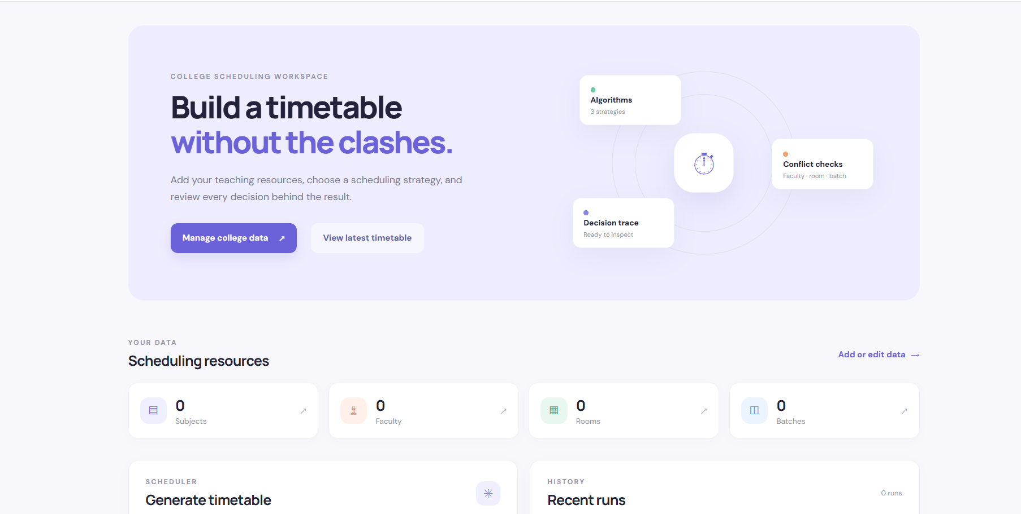
Figure 1. College Timetable Generator dashboard.

7. Conclusion, Future Scope & References

7.1 Conclusion
The College Timetable Generator demonstrates how algorithmic techniques can be applied to a practical academic scheduling problem. The project combines a web-based interface with scheduling algorithms and explicit conflict checking. The tested implementation successfully generated clash-free assignments for the sample fixture and respected faculty availability. It also handled an impossible schedule without crashing by returning partial scheduling information.

7.2 Future Scope
- Add role-based authentication for administrators, coordinators and faculty.
- Add richer validation and user-friendly error messages.
- Support multiple departments and academic years.
- Support lab periods, consecutive classes and room-type constraints.
- Add faculty workload limits and preferred teaching periods.
- Add automatic timetable optimization based on additional objectives.
- Add timetable export to PDF and Excel.
- Add timetable sharing and print-friendly views.
- Add larger-scale performance benchmarking.
- Deploy the application to a hosted environment.

7.3 References / Documentation
- College Timetable Generator problem statement and project brief supplied for the DAA project.
- Python Documentation – https://docs.python.org/3/
- Flask Documentation – https://flask.palletsprojects.com/
- SQLite Documentation – https://www.sqlite.org/docs.html
- pytest Documentation – https://docs.pytest.org/
- GitHub Documentation – https://docs.github.com/
GitHub Repository | Upload PPT, report and code
Project Details Sheet | Write the final GitHub repository link

